**MOBILE APPLICATION DEVELOPMENT**

**(MAD)**

Name : Sourjadip Pramanik

Div: R

Roll_No : 53

ASSIGNMENT NO.6

# Assignment Name :Implement an application that writes data to the SD card.

As I don’t have SD card I have stored the data in Internal storage

Code For Manifest File :

<?*xml version*="1.0" *encoding*="utf-8"?>

<manifest *xmlns:android*="http://schemas.android.com/apk/res/android"

*package*="com.example.file_read_write">

<application

*android:allowBackup*="true"

*android:icon*="@mipmap/ic_launcher"

*android:label*="@string/app_name"

*android:roundIcon*="@mipmap/ic_launcher_round"

*android:supportsRtl*="true"

*android:theme*="@style/Theme.File_read_write">

<activity *android:name*=".MainActivity">

<intent-filter>

<action *android:name*="android.intent.action.MAIN" />

<category *android:name*="android.intent.category.LAUNCHER" />

</intent-filter>

</activity>

</application>

</manifest>

Code For JAVA File : (MainActivity.java)

*package* com.example.file_read_write;

*import* androidx.appcompat.app.AppCompatActivity;

*import* android.os.Bundle;

*import* android.view.View;

*import* android.widget.Button;

*import* android.widget.EditText;

*import* android.widget.TextView;

*import* android.widget.Toast;

*import* java.io.BufferedReader;

*import* java.io.FileInputStream;

*import* java.io.FileNotFoundException;

*import* java.io.FileOutputStream;

*import* java.io.IOException;

*import* java.io.InputStreamReader;

*public class* MainActivity *extends* AppCompatActivity {

EditText inputField;

TextView displayText;

Button readButton,clearButton,writeButton;

@Override

*protected void* onCreate(Bundle savedInstanceState) {

*super*.onCreate(savedInstanceState);

setContentView(R.layout.*activity_main*);

inputField = findViewById(R.id.*input_field*);

writeButton = findViewById(R.id.*write_button*);

displayText = findViewById(R.id.*display_text*);

readButton = findViewById(R.id.*read_button*);

clearButton = findViewById(R.id.*button*);

writeButton.setOnClickListener(*new* View.OnClickListener() {

@Override

*public void* onClick(View view) {

writeFile();

}

});

readButton.setOnClickListener(*new* View.OnClickListener() {

@Override

*public void* onClick(View view) {

readFile();

}

});

clearButton.setOnClickListener(*new* View.OnClickListener() {

@Override

*public void* onClick(View v) {

clear();

}

});

}

*public void* writeFile() {

String textToSave = inputField.getText().toString();

*try* {

FileOutputStream fileOutputStream = openFileOutput("Mad Lab File.txt", *MODE_PRIVATE*);

fileOutputStream.write(textToSave.getBytes());

fileOutputStream.close();

Toast.*makeText*(getApplicationContext(), "Text Saved", Toast.*LENGTH_SHORT*).show();

inputField.setText("");

} *catch* (FileNotFoundException e) {

e.printStackTrace();

} *catch* (IOException e) {

e.printStackTrace();

}

}

*public void* readFile() {

*try* {

FileInputStream fileInputStream = openFileInput("Mad Lab File.txt");

InputStreamReader inputStreamReader = *new* InputStreamReader(fileInputStream);

BufferedReader bufferedReader = *new* BufferedReader(inputStreamReader);

StringBuffer stringBuffer = *new* StringBuffer();

String lines;

*while* ((lines = bufferedReader.readLine()) != *null*) {

stringBuffer.append(lines + "\n");

}

displayText.setText(stringBuffer.toString());

} *catch* (FileNotFoundException e) {

e.printStackTrace();

} *catch* (IOException e) {

e.printStackTrace();

}

}

*public void* clear(){

inputField.setText("");

}

}

Code For XMl File : (activity_main.xml)

<?*xml version*="1.0" *encoding*="utf-8"?>

<androidx.constraintlayout.widget.ConstraintLayout *xmlns:android*="http://schemas.android.com/apk/res/android"

*xmlns:app*="http://schemas.android.com/apk/res-auto"

*xmlns:tools*="http://schemas.android.com/tools"

*android:layout_width*="match_parent"

*android:layout_height*="match_parent"

*android:background*="#03A9F4"

*tools:context*=".MainActivity">

<EditText

*android:id*="@+id/input_field"

*android:layout_width*="302dp"

*android:layout_height*="53dp"

*android:layout_marginStart*="8dp"

*android:layout_marginTop*="96dp"

*android:layout_marginEnd*="8dp"

*android:ems*="10"

*android:hint*="Input"

*android:inputType*="textPersonName"

*app:layout_constraintEnd_toEndOf*="parent"

*app:layout_constraintHorizontal_bias*="0.497"

*app:layout_constraintStart_toStartOf*="parent"

*app:layout_constraintTop_toTopOf*="parent" />

<Button

*android:id*="@+id/write_button"

*android:layout_width*="wrap_content"

*android:layout_height*="wrap_content"

*android:layout_marginTop*="60dp"

*android:text*="Save"

*app:backgroundTint*="#FF9800"

*app:layout_constraintEnd_toStartOf*="@+id/button"

*app:layout_constraintStart_toStartOf*="parent"

*app:layout_constraintTop_toBottomOf*="@+id/input_field" />

<TextView

*android:id*="@+id/display_text"

*android:layout_width*="352dp"

*android:layout_height*="140dp"

*android:layout_marginStart*="8dp"

*android:layout_marginTop*="52dp"

*android:layout_marginEnd*="8dp"

*android:gravity*="center"

*android:hint*="Mad Lab File.txt"

*android:textSize*="20sp"

*android:textStyle*="bold"

*app:layout_constraintEnd_toEndOf*="parent"

*app:layout_constraintHorizontal_bias*="0.488"

*app:layout_constraintStart_toStartOf*="parent"

*app:layout_constraintTop_toBottomOf*="@+id/write_button" />

<Button

*android:id*="@+id/read_button"

*android:layout_width*="wrap_content"

*android:layout_height*="wrap_content"

*android:layout_marginStart*="8dp"

*android:layout_marginTop*="40dp"

*android:layout_marginEnd*="8dp"

*android:text*="Read"

*app:backgroundTint*="#CD1515"

*app:layout_constraintEnd_toEndOf*="parent"

*app:layout_constraintHorizontal_bias*="0.501"

*app:layout_constraintStart_toStartOf*="parent"

*app:layout_constraintTop_toBottomOf*="@+id/display_text" />

<Button

*android:id*="@+id/button"

*android:layout_width*="wrap_content"

*android:layout_height*="wrap_content"

*android:layout_marginTop*="60dp"

*android:layout_marginEnd*="80dp"

*android:layout_marginRight*="80dp"

*android:text*="Clear"

*app:backgroundTint*="#E91E63"

*app:layout_constraintBottom_toTopOf*="@+id/display_text"

*app:layout_constraintEnd_toEndOf*="parent"

*app:layout_constraintTop_toBottomOf*="@+id/input_field"

*app:layout_constraintVertical_bias*="0.0" />

</androidx.constraintlayout.widget.ConstraintLayout>

SCREENSHOTS

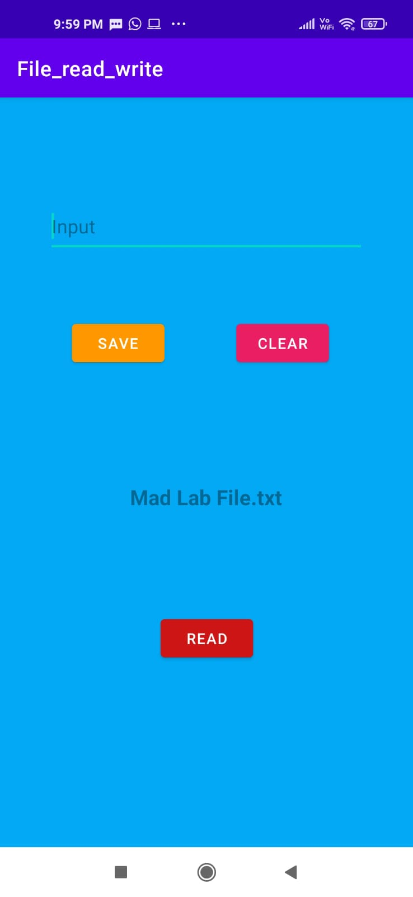 Opening the app

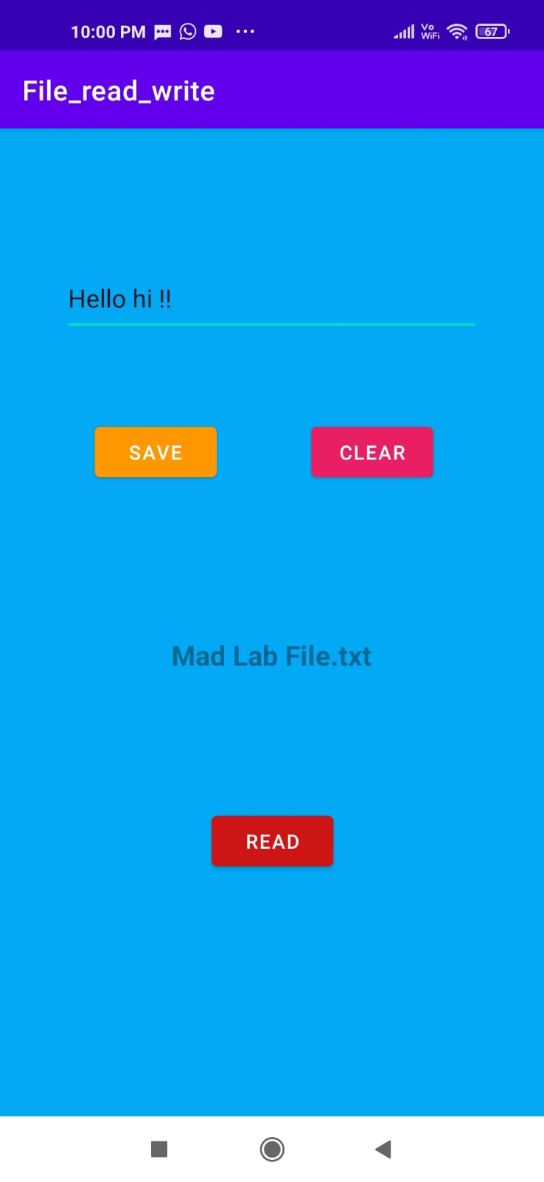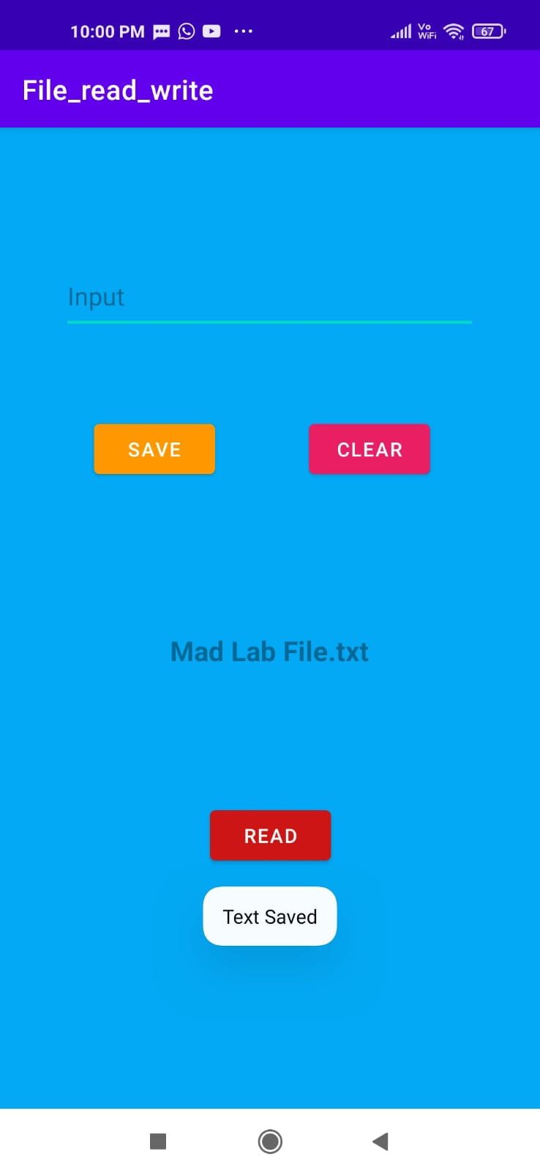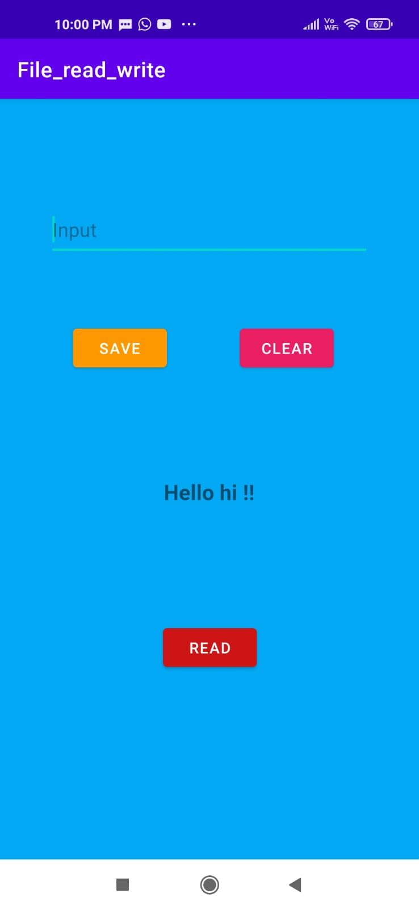

Typing data After Saving Data Read Data